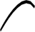

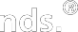

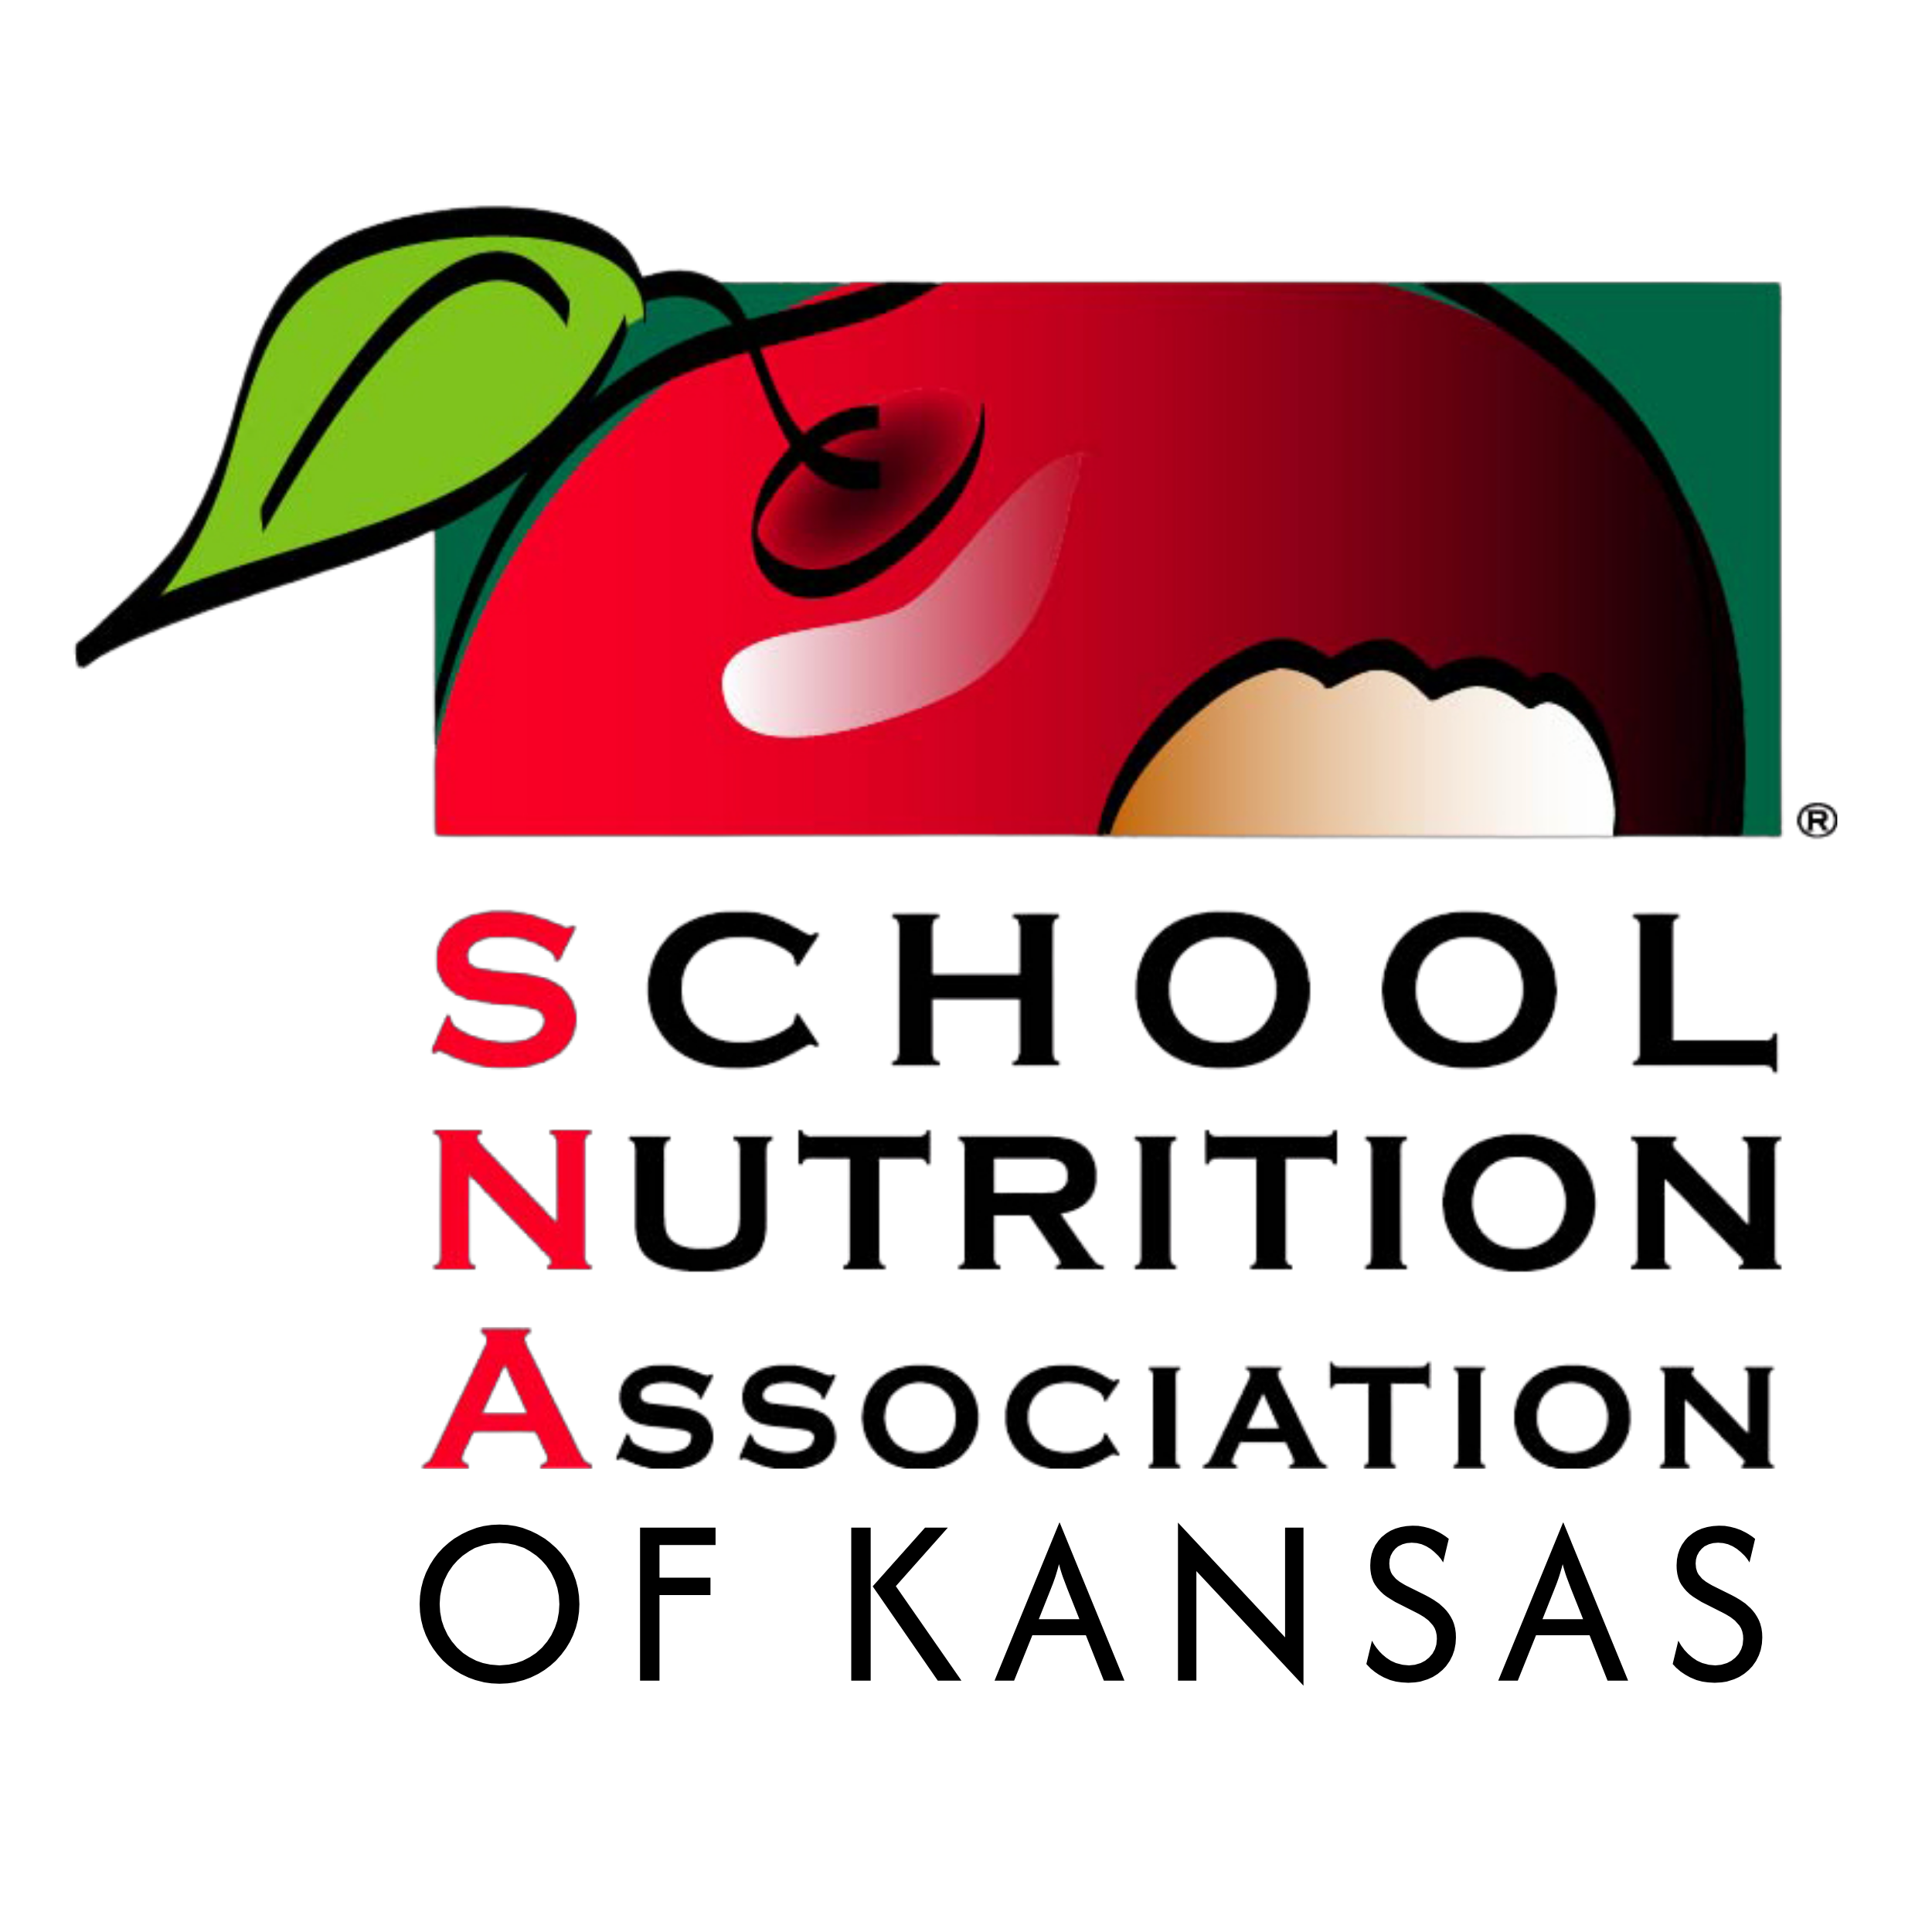School Nutrition Association of Kansas

SNA-KS 2025 Plan of Action

Margery Erckert
SNA-KS
President

School Nutrition Association’s (SNA) core purpose, vision, mission, and core values. As an affiliate of SNA, the School Nutrition Association of Kansas
(SNA-KS) has agreed to embrace these fundamental principles and apply them to our state association.

The School Nutrition Association’s Mission is to empower and support school nutrition professionals in advancing the accessibility, quality, and integrity of school nutrition programs.
Our vision is for every student to have access to nutritious meals at school, ensuring their optimal health and well-being.
Our CORE PURPOSE is to have well-nourished students, prepared to succeed.
Our CORE VALUES include:
Integrity and Ethics: Act ethically and responsibly, always.
Inclusion- Embrace different perspectives and ideas from SNA’s diverse membership Collaboration- Share strategies and solutions to achieve professional excellence.
Commitment- Embody care and compassion for student well-being.
Innovation- Drive change with creativity and strategic thinking.
Courage- Resolve to protect and defend school nutrition programs.

A r e A S O f
Voice of School Nutrition
f O c u S

Career Development and Growth

Cr os s C utting Themes
- Equity, Diversity, and Inclusion
- Fiscal responsibility, Financial sustainability, SN foundation
- Meaningful communications,
Marketing, and Outreach
- Relevant Digital Experiences

Thriving Organization
Stakeholder Community

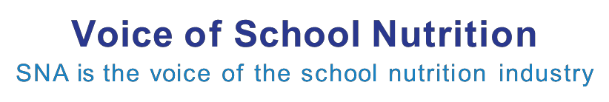School Nutrition Association of Kansas

Area of Focus I: Voice of School Nutrition
SNA Objective:
- We are advocates for feeding our country’s future.
- We elevate the professional image of school nutrition, both inside and outside of the industry.
- We are universally acknowledged and recognized school nutrition expert.

SNA-KS’s Strategy | Priority assigned to: | Major Steps/Timeline | Evaluation
Promote SNA-KS at State Capitol to advance legislative objectives and increase visibility. | PP&L Chair and Committee,  Executive Board | Schedule day to invite your legislator to school lunch and plan a legislative day at the capital for SNA-KS in March. | Survey, PP&L committee and attendees for feedback to improve following year’s visit.
School Year visits/ emails/ phone calls Congresspeople and Senators. | Executive Board, Area Representatives, PP&L Chair and Committee | Reach out to local offices of National Representatives, during school year. Use SNA legislative alerts. | Feedback at April Meeting from area representatives.
Promote SNA- KS’s programs, goals and achievements through social media mediums, such as Facebook and Instagram. | SNA-KS Communications Chair, Area Representatives , Sea Social | Encourage disticts to submit information. Share information to encourage participation at October conference. | Member survey and feedback of committees and participants.
Edit the SNA-KS website to be user friendly and eye catching and up to date. | SNA- KS Communications Chair and Committee and Sea Social. | Continue to work with Sea Social to keep the Website current. | Member survey and feedback.

School Nutrition Association of Kansas

Area of Focus II: Career Development and Growth
SNA supports the professional growth and career pathways of members.

SNA Objectives:
  - We serve as the hub for members to network and build lifelong relationships around common goals and interests.
  - We create opportunities for professional growth for members and build their capacity to lead in their schools and districts.

Career Development and Growth

SNA-KS’s Strategy Priority assigned to: Major Steps/Timeline Evaluation

Implement a Kansas State Future Leaders Program for the summer of 2026

Continue to Promote the SNA Certificate and SNS Credential Program
Nutrition/ Education Committee, Membership Committee, Future Leadership Advisory board.
Executive Board, Area Representatives, Nutrition / Education Chair.
Develop a plan and a budget by Jan meeting.

Promote SNA Certificate and SNS credentialing program at SNA-KS State Conference 2025
Complete training and workshop evaluations.

SNA data

Coordinate with KSDE for Training and Workshops
Nutrition/ Education Chair, DDS Rep and Employee/ Manager Rep, President- elect
Work to encourage that training is offered during the school year, as well as at conference.
Directors, managers, and staff complete workshop evaluations.

School Nutrition Association of Kansas

Area Focus III: Stakeholder Community
SNA cultivates a vibrant community of school nutrition stakeholders.
SNA Objectives:
- We have redefined and elevated the relationship and partnership with industry
- We influence, convene, and connect stakeholders who seek to shape the school nutrition industry.

Career Development and Growth

SNA-KS’s Strategy | Priority assigned to: | Major Steps/Timeline | Evaluation
Promote Industry Member Involvement | Industry Membership Chair, Industry Advisory Board, Executive Committee | Invite industry to join Industry Advisory Board. Have at least two members on advisory board by Oct 2025 | Vendor Feedback
Promote vendor visibility to membership | Membership Chair, Membership Committee , Communications Commitee and President | Quarterly digital newsletter advertisement opportunities. | Website, Facebook and Instagram
Facilitate Industry Membership Relaunch | Industry Member Chair, Industry Advisory Board, Executive Committee | Meet with Industry Advisory Board to discuss strategy. Use October Conference to relaunch Industry Membership. | Vendor survey and feedback.

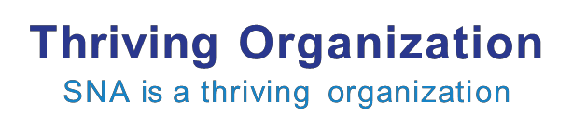School Nutrition Association of Kansas

Area of Focus IV: Thriving Organization
SNA is a thriving organization.

SNA Objectives:
- We have a strong and varied pathway to volunteer leadership and provide inclusive
opportunities for contribution.
- We are a digital-first organization with a strong, nimble technology infrastructure and efficient processes.
- We look for ways to disrupt our own business models, leading the way to innovation and new revenue opportunities.

SNA-KS’s Strategy | Priority assigned to: | Major Steps/Timeline | Evaluation
Increase recruitment efforts to identify future state leaders via social media, email and regional meetings. | President,Membership Chair, Membership Committee , Regional Representatives, and Furtue Leaders Advisory Board | Recruit diverse leadership/talent at conference and SNA-KS workshops to attend leadership training via email, Facebook, and Instagram .  Initiate aggressive digital and hands on recruitment of all new school directors. | Membership Feedback
Increase membership by 3% | Membership Chair, Membership Committee, Area Representatives, and President | Visit each region, promote membership and district owned membership through website, social media. Identify and target districts with low membership. | SNA Member reports

Increase transparency of Executive Board | President, President - Elect Communications Chair | Town hall meeting at conference to address member questions.  State of SNA - KS affairs reports will be sent to membership biannually. Once in December 2025 and in June 2026 | Town Hall Biannual Report
Digitize conference registrations | President, President-elect,  Communications Chair | Implement digital registration for vendors and attendees for all shows and conferences. | Member survey and feedback
Increase efforts to locate outside funding sources. | Executive Board | Research available sources for grants to advance SNA- KS mission and goals. Set up digital donations for SNA-KS scholarship program. | Profit / Loss Report

